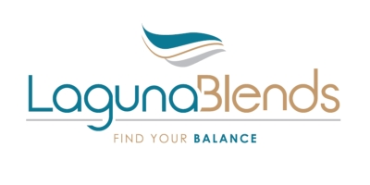
LAGUNA BLENDS ANNOUNCES ADDITIONAL LOANS OF $130,000
KELOWNA, BC – April 1, 2016 – Laguna Blends Inc. (CSE: LAG) (the “Company” or “Laguna”) announces that Laguna Blends (USA) Inc. (“Laguna USA”), a wholly-owned subsidiary of the Company, has entered into additional secured loan agreements pursuant to which the lenders have loaned an aggregate of $130,000 to Laguna USA which loans bear interest at 10% per annum. Proceeds of the loans are intended to be used for general working capital purposes. The Company also announces that it is not proceeding with the remainder of its previously announced private placement equity financing as disclosed on March 2nd and March 14th.
About Laguna Blends Inc.
Laguna is a network marketing company that generates retail sales through independent affiliates. Affiliates utilize tools and technology that enable them to build an international business from their own home or while travelling. This technology replaces the need for expensive travel and hotel meetings.
The Company is currently focused on the nutritional health benefits derived from hemp. Laguna’s first product category as an entry to market are functional beverage products that contain hemp and other efficacious ingredients.
ON BEHALF OF THE BOARD
"Stuart Gray"
President, Chief Executive Officer,
Chief Financial Officer and Director

FOR INVESTOR RELATIONS INFORMATION PLEASE CONTACT:
QualityStocks
Scottsdale, Arizona
www.QualityStocks.com
480.374.1336 Office
Editor@QualityStocks.net

www.lagunablends.com
Forward-Looking Information:|
This news release contains "forward-looking information" within the meaning of applicable securities laws relating to statements regarding the Company's business, products and future plans including, without limitation, statements regarding use of proceeds, the expected launch date for the Company’s business, its product offerings and plans for sales and marketing. Although the Company believes that the expectations reflected in the forward looking information are reasonable, there can be no assurance that such expectations will prove to be correct. Readers are cautioned to not place undue reliance on forward-looking information. Such forward looking statements are subject to risks and uncertainties that may cause actual results, performance and developments to differ materially from those contemplated by these statements depending on, among other things, the risks that the Company's products and plan will vary from those stated in this news release and the Company may not be able to carry out its business plans as expected. Except as required by law, the Company expressly disclaims any obligation, and does not intend, to update any forward looking statements or forward-looking information in this news release. The statements in this news release are made as of the date of this release.

